Zenit-12C
Camera identical to Zenit-12, but used in FS-12 (Photosnaiper) set. Less common than Zenit-12S with markings in Roman characters [1].
Produced: 1982-1990  Name: „Зенит-12С“  Producer: KMZ  Frame size: 24x36.  Lens: Helios-44M-4 2/58.  Shutter: 1/30s-1/500s + B.  Quantity: 118.486 units. | 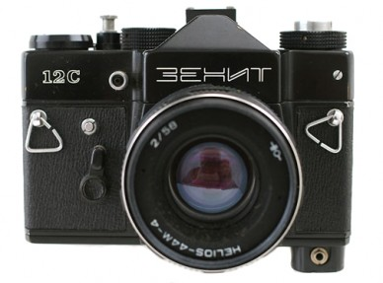
 | Zenit-12C #86020636.

